NATIONAL UNIVERSITY OF SCIENCES AND TECHNLOGY

(DEPARTMENT OF MECHANICAL ENGINEERING)

FUNDAMENTALS OF PROGRAMMING

NAME: SYED ALI NAQI

ID: 466889

SECTION: B

**TASK 1:**

#include <iostream>

#include <cmath>

using namespace std;

int main (){

int num, j;

int sum=0;

for(num=2; num<=50; ++num){

bool isPrime= true;

for(j=2;j<=num/2; ++j){

if(num % j==0){

isPrime=false;

break;}

}

if (isPrime){

sum +=num ;}

}

cout <<sum <<" is the sum of prime numbers between 1 and 50."<<endl;

return 0;

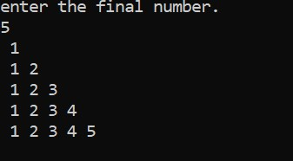

**TASK 2**:

#include <iostream>

#include <cmath>

using namespace std;

int main (){

int number, a, b;

cout <<"enter the final number."<<endl;

cin>>number;

for( a=1;a<=number ;a++){

for( b=1;b<=a;b++){

cout <<" "<<b;

}

cout<<endl;

}

return 0;

}

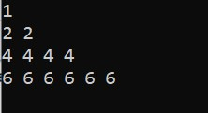**Task 3:**

#include <iostream>

using namespace std;

int main (){

cout <<"1"<<endl;

for( int i=1;i<=3; i++){

for (int j=1;j<=i*2;j++){

cout<<i*2<<" ";

}

cout <<endl;

}

return 0;

}